# Main screen

# Create user activity

# Validation error

# User created successfully

# Login Invalid Credentials

# Valid email login / Product category page

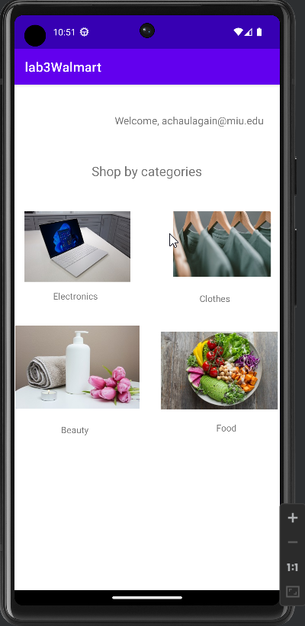

# User selects electronics category

